Ampt Kids Church – Sunday 5 September 2021
Welcome
Welcome to Ampt with Ruth. I hope that you have all wished your dad a very Happy Father’s Day and thanked him for being the best dad!

Prayer
Dear Lord God, we thank you for our dads and for their love for us. Please help us to understand and learn from the Bible passages today. In Jesus name, Amen.

Revision
Can you remember from last week’s lesson what the consequences were when King Solomon disobeyed God by marrying women who worshipped false gods?

Introduction
Over 700 years before the time of Jesus, the prophet Isaiah told the people to expect a Messiah, that is the one God promised to send to rescue his people.
In today’s Bible passages from Isaiah 61:1,2 in the Old Testament and Luke 4:16-22 in the New Testament, we see how God keeps his promises.

Video
Bible Story, "Jesus' Mission," Luke 4:16-21 - YouTube
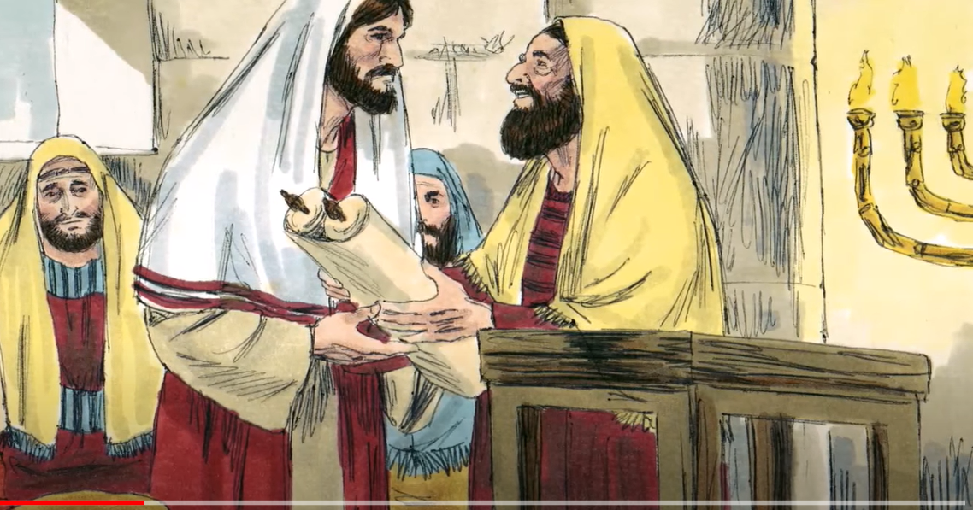

Bible reading – Luke 4:16-22
¹⁶ He went to Nazareth, where he had been brought up, and on the Sabbath day he went into the synagogue, as was his custom. He stood up to read, ¹⁷ and the scroll of the prophet Isaiah was handed to him. Unrolling it, he found the place where it is written:
¹⁸ “The Spirit of the Lord is on me, because he has anointed me to proclaim good news to the poor.
He has sent me to proclaim freedom for the prisoners
and recovery of sight for the blind, to set the oppressed free, ¹⁹ to proclaim the year of the Lord’s favor.”
²⁰ Then he rolled up the scroll, gave it back to the attendant and sat down. The eyes of everyone in the synagogue were fastened on him. ²¹ He began by saying to them, “Today this scripture is fulfilled in your hearing.”
²² All spoke well of him and were amazed at the gracious words that came from his lips. “Isn’t this Joseph’s son?” they asked.
Questions
Q1. Who was the one predicted in the Old Testament book of Isaiah 700 years previous?
Q 2. What did God send Jesus to do?

Prayer
Dear Lord God, we thank you that you had a plan, which came with a promise given to the prophet Isaiah hundreds of years before sending your Son, Jesus, to rescue us from the consequences of the wrong things that we think, say and do. Amen.

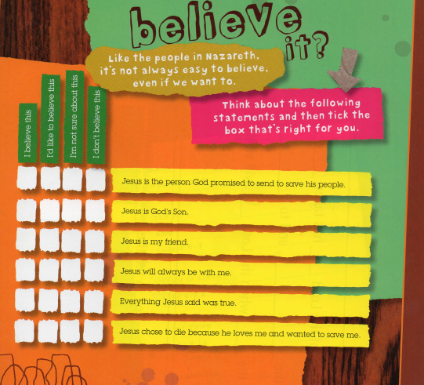

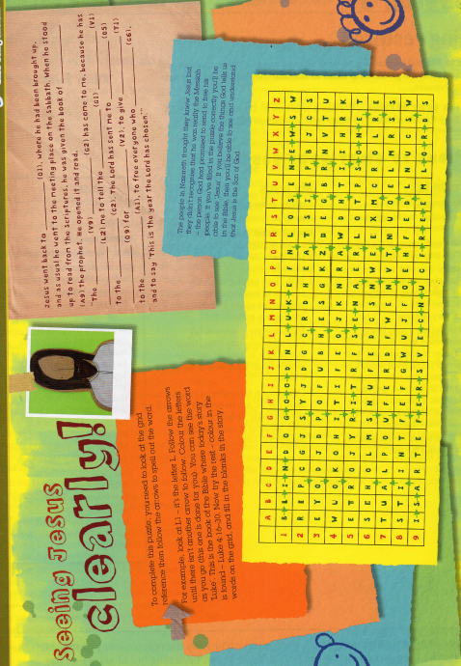
Father’s Day Activities

Gift Certificate – See attachment
You don’t need to spend lots of money to give your dad a wonderful present that he will love and appreciate. Here are some suggestions for what you could give on the certificate.
Breakfast in bed, a job of your choice, help to clean the car, a big HUG, help to cook pancakes or muffins or dad’s favourite food.

Father’s Day Card – See attachment
You can print the card, add your special message and draw a picture of dad’ s favourite activity, hobby or sport OR make dad a card using your own artistic gifts.

