Jesus: Our Best Friend

Come and discover the BEST reason to love Jesus, over these next 7 lessons.

Lesson #2. Being Included

1. PRAY
Jesus, we thank you for your love and care for us. Help us now to learn about you, to build up our love and trust in you.

2. THINK
What if you are different to other people? Have you been left on the outside of a group? Have you been told to “go away”? Have you felt racism?

3. READ

Matthew 15:21-28

International Children’s Bible

Jesus Helps a Non-Jewish Woman
²¹ Jesus left that place and went to the area of Tyre and Sidon. ²² A Canaanite woman from that area came to Jesus. The woman cried out, “Lord, Son of David, please help me! My daughter has a demon, and she is suffering very much.”
²³ But Jesus did not answer the woman. So the followers came to Jesus and begged him, “Tell the woman to go away. She is following us and shouting.”
²⁴ Jesus answered, “God sent me only to the lost sheep, the people of Israel.”
²⁵ Then the woman came to Jesus again. She bowed before him and said, “Lord, help me!”
²⁶ Jesus answered, “It is not right to take the children’s bread and give it to the dogs.”
²⁷ The woman said, “Yes, Lord, but even the dogs eat the pieces of food that fall from their masters’ table.”
²⁸ Then Jesus answered, “Woman, you have great faith! I will do what you asked me to do.” And at that moment the woman’s daughter was healed.

4. CLUES
¹ Jesus goes to Tyre and Sidon to get some rest, away from the people who are crowding him because of his miracles (eg. feeding the 5000).

² The Canaanites and the Israelites are NOT friends at all. The Israelites believed only they would receive the blessings and promises of God.

³ Jesus seems to be very rude to this woman. Did you feel it in verses 24 and 26?

⁴ The Canaanite woman was not giving up! She WANTED Jesus’ help for her daughter and was able to change Jesus’ mind about including non-Jews in his circle.

5. WATCH

https://www.youtube.com/watch?v=JD066ml5SoU

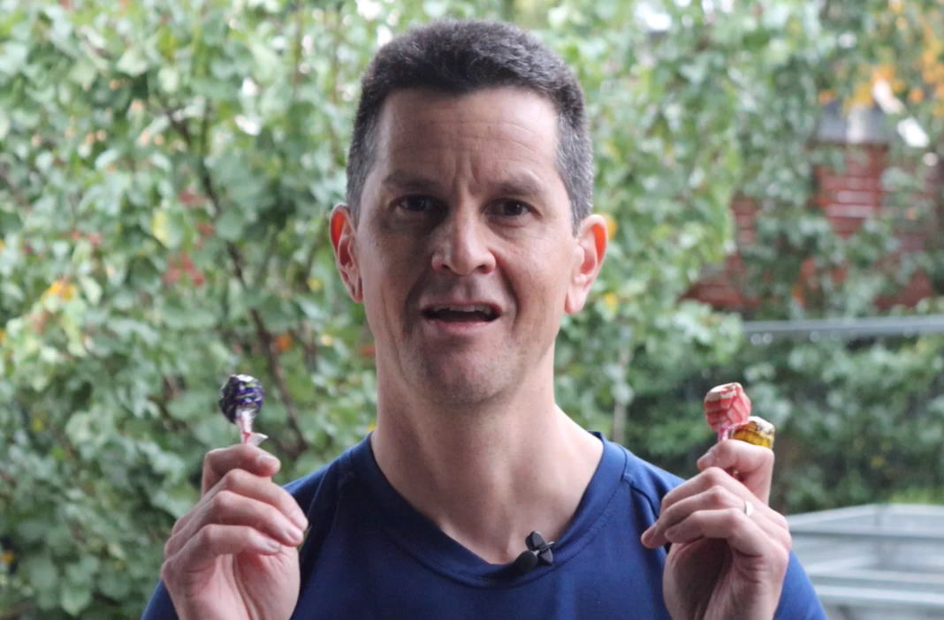

6. QUIZ
1. Were Canaanites and Israelites the same or different groups of people?

2. Why did Jesus help this Canaanite woman?

3. How does this story change your understanding of whom Jesus came to earth to help and save?

7. SHARE THE STORY
Colour the next page and fold it to create a story book.

