AMPT Kids Church – 3 October 2021

Welcome
Welcome to Ampt with Ruth. I hope that you have enjoyed the school holidays and been able to enjoy lots of outdoors time.
Prayer
Dear Lord Jesus, we thank you for the holiday time and ask that you would help us to understand today’s Bible passage and be able to put it into practice. In Jesus’ name, amen.

Introduction
In Jesus’ time, if someone visited your home, it was the custom for a slave to remove a guest’s sandals, wash their feet in a bowl of water and dry them with a towel. This was because the weather was hot and people wore open sandals. The roads were dusty and so their feet would soon get dirty. Guests were also greeted with a kiss on each cheek.

Bible passage – Luke 7:36-50
³⁶ A Pharisee invited Jesus to have dinner with him. So Jesus went to the Pharisee’s home and got ready to eat.
³⁷ When a sinful woman in that town found out that Jesus was there, she bought an expensive bottle of perfume. ³⁸ Then she came and stood behind Jesus. She cried and started washing his feet with her tears and drying them with her hair. The woman kissed his feet and poured the perfume on them.
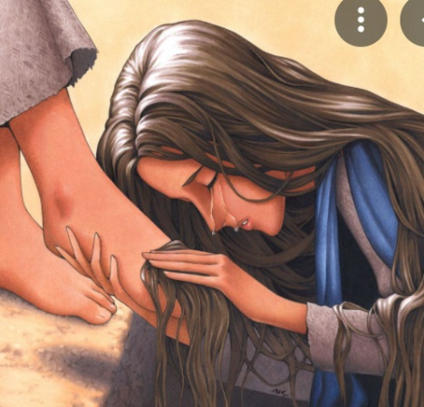
³⁹ The Pharisee who had invited Jesus saw this and said to himself, “If this man really were a prophet, he would know what kind of woman is touching him! He would know that she is a sinner.”
⁴⁰ Jesus said to the Pharisee, “Simon, I have something to say to you.”
“Teacher, what is it?” Simon replied.
⁴¹ Jesus told him, “Two people were in debt to a moneylender. One of them owed him five hundred silver coins, and the other owed him fifty. ⁴² Since neither of them could pay him back, the moneylender said that they didn’t have to pay him anything. Which one of them will like him more?”
⁴³ Simon answered, “I suppose it would be the one who had owed more and didn’t have to pay it back.”
“You are right,” Jesus said.
⁴⁴ He turned toward the woman and said to Simon, “Have you noticed this woman? When I came into your home, you didn’t give me any water so I could wash my feet. But she has washed my feet with her tears and dried them with her hair. ⁴⁵ You didn’t greet me with a kiss, but from the time I came in, she has not stopped kissing my feet. ⁴⁶ You didn’t even pour olive oil on my head, but she has poured expensive perfume on my feet. ⁴⁷ So I tell you that all her sins are forgiven, and that is why she has shown great love. But anyone who has been forgiven for only a little will show only a little love.”
⁴⁸ Then Jesus said to the woman, “Your sins are forgiven.”
⁴⁹ Some other guests started saying to one another, “Who is this who dares to forgive sins?”
⁵⁰ But Jesus told the woman, “Because of your faith, you are now saved. May God give you peace!”

Video – Luke 7:36-50
The Parable of the Two Debtors - YouTube
https://www.youtube.com/watch?v=WTTFtlsz6i4

Comment
Like the woman in this Bible passage, we don’t need to be good to come to Jesus. We can come with all our faults and failings and be forgiven when we have faith that Jesus is the powerful Son of God.

Circle True or False
- Jesus told the parable of the money lender to help the Pharisees understand the woman’s reason for such love and thankfulness. True or false?
- The woman in this Bible passage had lived a good life. True or false?
- She knelt at Jesus feet and cried so much that her tears wet his feet. True or false?
- Jesus said to the woman, your sins are forgiven. True or false?
- When we do, say or think anything that is bad or unkind, and ask God to forgive us, he will. True or false?

Prayer
Dear Lord Jesus, we thank you for your forgiveness of the woman in today’s Bible passage. We thank you that you forgive everyone, including me, who believes in you and asks for your forgiveness. Amen.

Word Search – Luke 7

